Submission Date: June 27, 2022

Submitted to:   
**Anastasia**

Proposal for **Shopify E-Commerce Web Platform**

* Custom UI/ UX
* Responsive HTML
* Shopify Frontend Web Platform Development
* Shopify Admin Panel Management
* Enterprise Architecture and Database Design

Submitted By:   
**Parva Pandya**

# Document Control

|  |  |  |
| --- | --- | --- |
| **Reference No.** | 2706202201 | |
| **Security Set:** | Confidential | |
| **Issue Date:** | June 27, 2022 | |
| **Current Version** | 1.0 | |
| **Author(s):** | **Name** | **Title** |
| Shyam Jasani | Sr. Business Analyst |
| **Issuer(s):** | **Name** | **Title** |
| Parva Pandya | Sr. Business Development Executive |
| **Distribution:** | **Name** | **Title** |
| Anastasia | Owner |
| Submitted to:  **Anastasia** | | |

# Version History

|  |  |  |  |  |
| --- | --- | --- | --- | --- |
| **Version No.** | **Author** | **Issuer** | **Updated Date** | **Change / Update** |
| 1.0 | Shyam Jasani | Parva Pandya | June 27, 2022 | Initial Draft |

# Table of Contents

## CONTENTS

Document Control 1

Version History 1

Table of Contents 2

CONTENTS 2

1 Company Overview 4

Clutch Profile: 4

2 Project Purpose 5

3 Project Features 6

3.1 Shopify E-Commerce Web Platform Requirement (Mind map) 6

3.2 Shopify E-commerce Web Platform Requirement Analysis 7

3.3 Shopify Admin Panel Management (Mind map) 25

3.4 Shopify Admin Panel Management 26

4 Team Details 35

5 Deliverables 36

6 Warranty 37

7 Maintenance Service Contract 38

8 Commercial Terms 39

8.1 Price & Timeline 39

8.2 Milestone 39

8.3 Payment Mode 39

9 Technology Stack 40

10 Our Portfolios 41

10.1 Mobile Application 41

10.2 Web Platform 42

11 Our Certification 43

12 Our Valuable Clients 44

13 Change Request Management 45

14 Exclusion 45

15 Assumption 46

16 Ownership 47

16.1 Publicity 47

16.2 References 47

17 Project Management Approach 48

17.1 Introduction 48

17.2 Project Monitoring and Tracking 49

17.3 Communication 51

18 Term And Condition 53

18.1 Terms of Acceptance 56

19 Acceptance Criteria and Procedure 57

# Company Overview

CMARIX is **ISO 9001:2015, ISO 27001 and CMMI Level 3** in process Technology Company based out from Ahmedabad, India. We are leading technology disruption with our clients across 46 countries globally. We are premium technology outsourcing company with in house team of **170+ engineers** and provide turnkey solutions in terms of all your technology needs.

**CMARIX** is glad to be considered in your search for a web platform technology partner in the development of **“Shopify E-Commerce Web Platform”.** We are very excited to become your technology partner by providing a best solution which meets your needs and expectation.

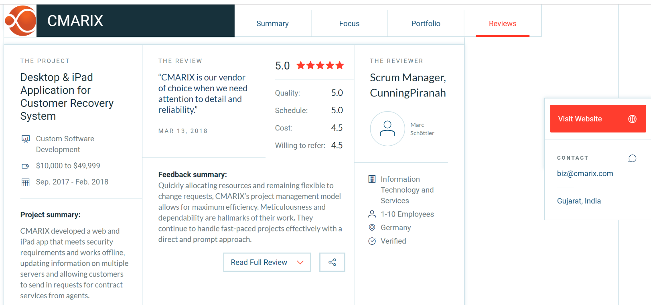

## Clutch Profile:

* To get more idea on the kind of projects which we have delivered, please refer to our clutch profile: <https://clutch.co/profile/cmarix>

# Project Purpose

The purpose of this project is to develop a Shopify E-Commerce Web Platform Development which will allow the customer to view all the different products of different category and sub-categories and view product detail information, purchase product one time or monthly recurring by making payment online and view order status & return it.

This project is for a create Shopify E-Commerce Web Platform Development which will be in English language only. Moreover, the Frontend web platform will be responsive so it will be providing accessibility on mobile & tablet devices.



# Project Features

## Shopify E-Commerce Web Platform Requirement (Mind map)

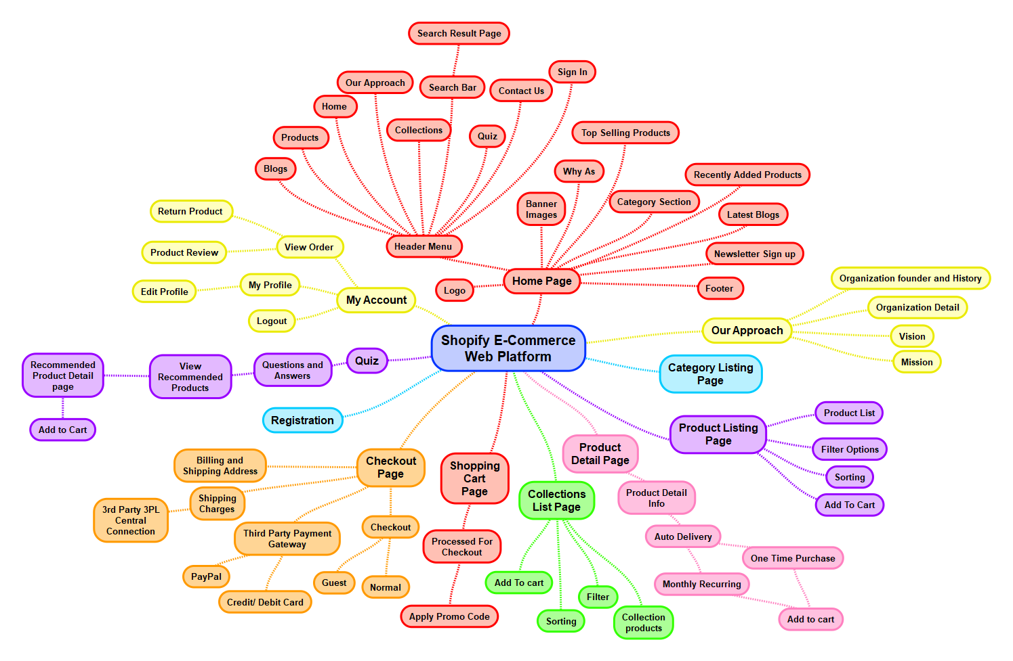

## Shopify E-commerce Web Platform Requirement Analysis

1. **HOME PAGE** 
   1. **LOGO**:
      1. Logo represents brand identity of the company’s website. On click of logo from any other page, it will navigate visitor to **“Home”** Page. Web Platform Logo and Favicon Logo will be provided by the client.
   2. **HEADER:**
      1. Header includes all the menu item with sub menu items:
         1. Home
         2. Our Approach
         3. Products (6 Vitamin products, and Collections)
         4. Quiz
         5. Blogs
         6. Contact Us
         7. Sign In
            1. Once visitor click on sign in button, the system will navigate the visitor to the “**Login**” page
         8. Search Bar
            1. Visitor can search product related information by entering keyword like **product name, category, and SKU Code** in search fields and system will find all related information from the database that are matched with entered keyword or name or SKU Code and display it into the search result page.
         9. Cart Icon
            1. By clicking on cart icon, the system will open a popup box where visitor can view recently added cart product with below details:

Product Thumbnail Image

Product Name

Product Category

Product Price

Quantity Selection Box

Remove Link or button

By clicking on review link or button, the system will remove that particular product from shopping cart.

View All Button

Once visitor click on view all button, the system will navigate the customer to the shopping cart page.

* 1. **BANNER**
     1. Visitor can view static 3 to 4 banner image with some static text and button with respective link.
     2. On click of button, it will navigate visitor to “**Product**” page.
     3. Static Banner image and Static text will be provided by the client.
     4. Banner images, text and content and button labels & link will be added and managed by administrator from Shopify admin panel
  2. **WHY US/ ABOUS US:** 
     1. Visitor should be able to view an organization related information on this section with read more button or link along with image.
     2. **Navigation:** Once visitor click on read more link or button, the system will navigate visitor to the About Us page.
     3. **Note:** 
        1. All content and images will be added and managed from the Shopify Admin panel.
        2. All content and image will be provided by the client
  3. **TOP SELLING PRODUCTS:**
     1. Visitor can view top 2 to 3 selling products in this section with below detail in this section:
        1. Product Image
        2. Product Name
        3. Product Price
        4. Add to Cart Button
           1. Once visitor click on cart icon, the system will add that particular product into shopping cart.
        5. View More
           1. Once visitor click on any product or view more link, system will navigate visitor to particular“**Product Detail**” page.
     2. Once visitor click on any product, system will navigate the visitor to “**Particular Product Detail**” page.
  4. **CATEGORY SECTION:**
     1. Customer should be able to view category section on home page with below details:
        1. Category Name
        2. Category Image
        3. View More
           1. Once customer click on view more link, the system will navigate customer to category listing page.
  5. **RECENTLY ADDED / NEW PRODUCTS:**
     1. Visitor can view 2 to 3 recently added products in this section with below detail in this section:
        1. Product Image
        2. Product Name
        3. Product Price
        4. Add to Cart button
           1. Once visitor click on cart icon, the system will add that particular product into the shopping cart.
        5. View More
           1. Once visitor click on any product or view more link, system will navigate visitor to particular“**Product Detail**” page.
     2. Once visitor click on any product, system will navigate the visitor to “**Particular Product Detail**” page.
  6. **LATEST BLOGS:**
     1. Visitor can view latest 3 blogs on home page bottom section with below details:
        1. Blog Image
        2. Blog Name
        3. Blog Category
        4. Blog Description (in 1 line)
        5. Read more link
           1. Once visitor click on read more link, system will navigate visitor to the blog detail page.
        6. View More Button
           1. Visitor can view a “View More” button at the top right side of this section.
           2. Once visitor click on view more button, the system will navigate visitor to the Blog Listing page.
        7. **Note**: All blog related details will be added and managed by administrator from Shopify admin panel.
  7. **NEWSLETTER SUBSCRIPTION FORM:** 
     1. Visitor can view an image with a Newsletter Subscribe Form on this section.
     2. Visitor should be able to subscribe for a newsletter sign up of organization by entering below form fields:
        1. Name
        2. Email Address
        3. Subscribe Button
     3. **Navigation:** 
        1. Once visitor enters value of above fields and click on subscribe button, the system will store all the data into the database and the visitor will subscribe for a newsletter subscription of the organization and receive newsletter email from the organization at a particular time period.
  8. **A FOOTER WILL HAVE:**
     1. Quick Links like Home, Product, Contact Us, Our Approach, Collections, and Blog
     2. Other Links
        1. Terms and Conditions
        2. Privacy Policy
        3. FAQs
        4. Return and Refund Policy
     3. Follow us Icon with their respective Links such as (Instagram, Facebook, Twitter, You Tube & Pinterest)
     4. Company Address information along with the email address, contact number and fax
     5. Copyright text

1. **OUR APPROACH:**
   1. Visitor can view a breadcrumb from home page to current page on this page.
   2. Visitor can view detailed information about organization with following sections and their respective content:
      1. Organization Founder and History
      2. Organization Detail
      3. Our Mission
      4. Our Vision
   3. **Note:** 
      1. All content and images of our approach page will be added and managed by administrator from Shopify admin panel.
      2. All the content and images of our approach page will be provided by client.
2. **SEARCH RESULT PAGE:**
   1. Visitor can view search field at the top of the listing page (Search Text box, Search Button)
   2. Visitor can search any product on this page by entering product name, category, SKU Code
   3. Visitor can view all the list of search result in this page for their particular search.
   4. The system will fetch all the data from database that are matched with entered keywords and display as a Search Result page in a list view.
   5. Search Result page layout will be same as product listing list page. Only title of product listing page will be replace with “Search Result” title.
3. **CATEGORY LIST PAGE:**
   1. Visitor can view a Breadcrumb from the home page to current page.
   2. Visitor can view different category list on this page with below details:
      1. Category Name
      2. Category Image
   3. Once visitor click on particular category, system will navigate visitor to their associated product listing page.
4. **PRODUCT LIST PAGE:**
   1. Visitor can view a Breadcrumb from the home page to current page.
   2. Visitor can view all the list (Grid of 3) of the different category products in this page with below details:
      1. Product Image
      2. Product Name
      3. Product Price
      4. Add to Cart Button or icon
         1. Once visitor click on cart icon or button, the system will add this particular product into the shopping cart.
   3. Once visitor click on any product, system will navigate visitor to **“Product Detail”** page.
   4. Visitor can view different filter option at the left side of product list page as below
      1. **Category / Sub Category:** 
         1. Visitor can view different category name with checkbox in this section as below:
         2. Visitor can checked multiple checkbox for category or sub–category from the available list.
         3. Once visitor checked any category name checkbox from available list and click on apply button, the system will display all the list of the product based on selected/ checked category.
      2. **Price Bar/ Price Range Scrollable bar** 
         1. Visitor can view Price range scrollable bar filter in this section.
         2. Visitor can add minimum and maximum price value by setting the scroll on the minimum and maximum value click on the apply button.
         3. Once visitor set the minimum and maximum price range scrollable bar and click on apply button, will system will display related product list to visitor based on the set price range on product listing page.
      3. **Availability Type** 
         1. Visitor can view following two type of checkbox for availability filters:
            1. Checkbox for “In Stock”
            2. Checkbox for “Out of Stock”
         2. Visitor can checked any one checkbox from available option.
         3. Once visitor checked any checkbox from available option and click on apply button, the system will display all the list of the product based on selected availability type.
   5. Visitor can view sorting dropdown option at the top right side of product listing page.
      1. Once visitor click on the sorting dropdown, the system will display following options to visitor:
         1. Price: High to Low
         2. Price: Low to High
         3. Newest
         4. Oldest
         5. Popular
      2. Based on selected sorting option system will display related product to visitor.
   6. Once visitor click on particular product name or image, the system will navigate visitor to the “**Product Detail”** page.
5. **COLLECTION PAGE:**
   1. Visitor can view a Breadcrumb from the home page to current page.
   2. Visitor can view all the list (Grid of 3) of the different collection products in this page with below details:
      1. Collection Product Image
      2. Collection Product Name
      3. Collection Product Price
      4. Add to Cart Button or icon
         1. Once visitor click on cart icon or button, the system will add this particular Collection product into the shopping cart.
   3. Once visitor click on any collection product, system will navigate visitor to **“Collection Product Detail”** page.
   4. Collection Details page will have same layout as Product detail page (as below)
   5. Visitor can view different filter option at the left side of product list page as below
      1. **Category / Sub Category:** 
         1. Visitor can view different category name with checkbox in this section as below:
         2. Visitor can checked multiple checkbox for category or sub–category from the available list.
         3. Once visitor checked any category name checkbox from available list and click on apply button, the system will display all the list of the collection product based on selected/ checked category.
      2. **Price Bar/ Price Range Scrollable bar** 
         1. Visitor can view Price range scrollable bar filter in this section.
         2. Visitor can add minimum and maximum price value by setting the scroll on the minimum and maximum value click on the apply button.
         3. Once visitor set the minimum and maximum price range scrollable bar and click on apply button, will system will display related collection product list to visitor based on the set price range on collection product listing page.
      3. **Availability Type** 
         1. Visitor can view following two type of checkbox for availability filters:
            1. Checkbox for “In Stock”
            2. Checkbox for “Out of Stock”
         2. Visitor can checked any one checkbox from available option.
         3. Once visitor checked any checkbox from available option and click on apply button, the system will display all the list of the collection product based on selected availability type.
   6. Visitor can view sorting dropdown option at the top right side of collection product listing page.
      1. Once visitor click on the sorting dropdown, the system will display following options to visitor:
         1. Price: High to Low
         2. Price: Low to High
         3. Newest
         4. Oldest
         5. Popular
      2. Based on selected sorting option system will display related collection product to visitor.
   7. Once visitor click on particular collection product name or image, the system will navigate visitor to the “**Collection** **Product Detail”** page.
6. **PRODUCT DETAIL PAGE:**
   1. Visitor can view a Breadcrumb from Home page to current page.
   2. Visitor can view particular product detail information on this page with the below details:
      1. Product Large Image
         1. Once visitor mouse hover on any large image, the system will display that image in a light box (Popup box)
      2. Product Thumbnail Images (Multiple Images)
         1. By clicking on thumbnail image, the system will display that particular image as a large image.
      3. Product Name
      4. Product SKU Code
      5. Product Category
      6. Available Stock
      7. Product Price
      8. Auto Delivery Options
         1. One Time purchase
         2. Monthly Recurring
      9. **Select Quantity Box with Plus and Minus Icon**
      10. **Add to Cart Button**
          1. Once visitor selects quantity of product and click on add to cart button, the system will add that particular product into shopping cart.
      11. Product Detail Description
   3. **Rating & Review Section:** 
      1. Visitor can view all the list of review and ratings of this particular product that are submitted by the different customer on the platform in this section with below details:
         1. Profile Picture of Review Submitted Customer
         2. Name of Customer
         3. Rating (From 1 to 5 star)
         4. Review
         5. Submitted Date and Time
      2. Visitor (as a Customer once they purchase a product) can add a review once they have purchased this product from the web platform and they are currently logged in into the web platform by entering the following form fields:
         1. Rating
         2. Review Description
         3. Submit Button
      3. Once visitor (as a Customer once they purchase a product) enters value of above fields and click on submit button, system will store details into database and the system will display that review in the rating & review management into the Shopify admin panel
      4. Once admin approve a particular review, it will be visible on the platform under a particular product detail page.
   4. **Related Products:** 
      1. Visitor should be able to view 3 to 5 related products on bottom of this page with below details:
         1. Product Image
         2. Product Name
         3. Product Price
         4. **Add To Cart button or icon**
            1. Once visitor click on add to cart button, the system will add that particular product into the shopping cart
      2. Once visitor click on particular related product, the system will navigate visitor to that particular related product detail page.
   5. **Note**:
      1. CMARIX will create all the product images for the web platform.
      2. Client will provide a logo, brand guidelines, and our product label (vitamin bottle label) in .AI format and using this CMARIX will create a Product Image.
      3. All the Product Images that are created by CMARIX will be shared with client for confirmation.
      4. All product related information will be added and managed by the administrator from Shopify admin panel.
7. **SHOPPING CART PAGE:**
   1. Visitor can view all the list of products that they have added into the cart on this page with below details:
      1. Product Thumbnail Image
      2. Product Name
      3. Product Category
      4. Product Price
      5. Selected Quantity along with the quantity box
         1. Visitor can view quantity box with minus and plus icon
         2. Visitor can view can either increase or decrease the particular product quantity from the available list by clicking on plus and minus icon
         3. Based on increase or decrease of product quantity, total amount price be changes on this page.
      6. Tax Amount
      7. Total Amount
   2. Visitor can view cart summary with subtotal amount, estimating shipping, estimated tax and discount.
   3. Visitor can remove particular product from the available cart list by clicking on remove link or button.
   4. **Apply Promo Code Section:** 
      1. Visitor can view Apply Promo Code section on the shopping cart page
      2. Visitor can be able to apply a promo code and discount code on this apply promo code field
      3. Once visitor enter promo code and click on apply button, the system will first check that promo code is valid or not
         1. If promo code is valid then a particular percentage or discount or flat amount will be deducted from total amount and visitor should be able to view final amount.
         2. If promo code is invalid then the system will display an error “**Promo code is not valid**” validating message to the visitor.
   5. Visitor can view following two button at the bottom of the page.
      1. Continue Shopping
      2. Checkout
   6. Once visitor click on continue shopping button, system will navigate visitor to the “**Product List**” page.
   7. Once visitor click on checkout button, the system will navigate visitor to the “**Checkout**” page
8. **CHECKOUT PAGE:**
   1. Visitor can purchase a product on the web platform using the following two ways
      1. Guest Checkout
         1. As a guest checkout, the system will allow the visitor to place the order on the web platform without login or registration on the web platform and need to enter the below required fields to place order
      2. Normal Checkout:
         1. For the normal checkout, the system will ask customer to enter their email address and password
         2. Once customer enter the email address and password, the system will check that this email address and password user and upon confirmation the system will display some of the below fields information will be pre-filled on the checkout page.
   2. Visitor/ Customer need to enter some of the below information to place the order on the web platform
      1. **Shipping Details:**
      2. First Name
      3. Last name
      4. Email Address
      5. Phone Number
      6. Address Line 1
      7. Address Line 2
      8. Town/ City Name
      9. State Name
      10. Country
      11. Zip Code
   3. Check box for “**Billing Address is same**?”
      1. If visitor/ customer checked above checked box then billing address will be same as shipping address.
      2. If visitor/ customer does not checked above checkbox then the Customer need to enter the below fields:
         1. First Name
         2. Last name
         3. Email Address
         4. Phone Number
         5. Address Line 1
         6. Address Line 2
         7. Town/ City Name
         8. State Name
         9. Country
         10. Zip Code
   4. Visitor/ Customer can view an order summary section with the below details:
      1. Product Thumbnail Image
      2. Product Name
      3. Product SKU Code
      4. Product Category
      5. Product Price
      6. Sub Total
      7. Shipping Charges
         1. Shipping Chagres will be calculated using **3PL Shipping Provider** on the web platform.
         2. To calculate the shipping charges we will integrate the 3rd party 3PL Central Software into the web platform using APIs
      8. Applied Promo Code
      9. Discount Amount
      10. Service Charges
      11. Delivery Charges
      12. Total / Final Amount
   5. Visitor/ Customer can view total payable amount with bifurcation i.e. estimated shipping charge, estimated tax (if applicable)
   6. Visitor/ Customer can make payment using the 3rd party **PayPal** Payment Gateway on the web platform
   7. On click of payment system will navigate visitor/customer to payment page.
   8. On successful payment, it will navigate visitor/customer to Thank you page along with continue shopping button which on click will navigate visitor/customer to “**Home**” page
   9. Visitor/ Customer will receive an invoice email for the purchased product order.
   10. The above process will be consider as a One-time purchase only for visitor/customer.
   11. If visitor/customer has selected auto delivery monthly recurring option, then the system will follow the below process:
       1. **Monthly Recurring Product purchase**
          1. If visitor/customer has purchase monthly auto delivery option then the will be receiving that product every month.
             1. **For example**: visitor/customer place an order on 1st September and select a monthly recurring auto delivery option then, in the next month 1st October system will generate a new order customer and the amount will be deducted from visitor/customer amount based on the selected payment gateway and product will be delivered to the visitor/customer.
             2. Also for October month purchase recurring product invoice will be sent to visitor/customer on their registered email address.
          2. Monthly recurring process will remain continue until the customer cancel the recurring process for particular product from my order section.
          3. Once visitor/customer cancelled monthly recurring purchase then from next month they will not receive a product and also no invoice will be generated.
   12. Once visitor/customer make payment on the web platform through the PayPal Payment Gateway, the system will send an email notification to admin for new order.
9. **QUIZ PAGE:**
   1. Visitor can view a Breadcrumb from Home page to current page.
   2. Visitor can view different type of questions on this page.
      1. Name
      2. Email Address
      3. Questions
         1. Question 1
         2. Answers 1
   3. Visitor can answers this questions on this page.
   4. At the bottom of the question answer form, visitor can view a “Submit button”.
   5. **Navigation**:
      1. Once visitor enters all questions answers and click on submit button, the system will store all the answers into the database and the system will navigate the visitor to the Quiz Result page.
   6. **Note**:
      1. We assume that all the questions will be provided by client at the time of the development.
      2. All the questions will be added and managed by administrator from shopify admin panel.
10. **QUIZ RESULT PAGE**
    1. Visitor can view a Breadcrumb from Home page to current page.
    2. Once visitor provide all the answers of the questions and click on submit button, they will be redirect to this page.
    3. Based on the visitor provided answers an algorithm runs in background and the system will provided a recommended products to the visitor on this page.
    4. Visitor can view all the list of the recommended products based on their provided answers
       1. Recommended Product Image
       2. Recommended Product Name
       3. Recommended Product Price
       4. **Add To Cart button or icon**
          1. Once visitor click on add to cart button, the system will add that particular Recommended product into the shopping cart
       5. Once visitor click on particular recommended product, the system will navigate visitor to that particular recommended product detail page.
    5. **Note**:
       1. **For recommended product listing based on the visitor submitted answers, client will provide an algorithm.**
       2. **We will just integrate the algorithm into the web platform.**
11. **BLOG LISTING PAGE** 
    1. Customer can view all the list of the published blogs on this page with the below details:
       1. Blog Thumbnail Image
       2. Blog Title
       3. Blog Category
       4. Blog Short Description
       5. Published Date and Time
       6. Read More Link or Button
    2. Customer can view more blogs by scrolling down on this page.
    3. Once customer scroll down on this page, the system will fetch all the other blogs data form database (Loading features).
    4. Once customer click on read more link or button, the system will navigate customer to the particular blog detail page.
12. **BLOG DETAIL PAGE**
    1. Customer can view particular blog detail information on this page with the below details:
       1. Blog Image
       2. Blog Title
       3. Blog Category
       4. Blog Publisher name
       5. Blog Published date and Time
       6. Blog Detail Description
    2. **Note:** All the blogs will be added and managed by administrator from the **Shopify** backend admin panel.
13. **CONTACT US**
    1. Customer can contact administrator regarding any query or message by entering following form fields:
       1. Your First Name
       2. Your Last Name
       3. Your Email Address
       4. Your Phone Number
       5. Subject
       6. Message
    2. After entering above information, once customer click on send button, system will sent an email to the administrator with above entered customer value.
    3. Apart from this customer can view address, contact information of the organization like email address, phone number, fax number, etc.
    4. Customer can view company or organization Address on Google Map with the location mark icon.
    5. To Display the Company Location on Google Map, the client will have to purchase the 3rd party Google Map APIs and provide us with necessary details.
14. **LOGIN PAGE**
    1. Customer can login into the system by entering below details.
       1. Email address
       2. Password
       3. Login Button
          1. Once customer enters value of above fields and click on login button, system will navigate customer to “**My Account”** Page.
       4. Forgot Password Link:
          1. Customer can view forgot password link under the login button.
          2. Once customer click on forgot password link, system will navigate customer to forgot password page.
       5. **Sign up/Registration:**
          1. Once customer click on Sign up link, system will navigate customer to sign up/ registration page.
15. **FORGOT PASSWORD:**
    1. Customer should be able to enter their email address to reset their credentials.
    2. Customer can enter following fields on this page to login reset their account credentials:
       1. Email Address
       2. **Reset button**: By clicking on reset button, the system will send an email to registered email address along with reset password link. By clicking on reset password link, the system will navigate customer to the Reset Password page.
16. **RESET PASSWORD:**
    1. Customer should be able to enter require fields to reset their account credentials.
    2. Customer can enter below fields on this page to reset their account credentials:
       1. New Password
       2. Confirm Password
       3. **Update button:** By clicking on update button, the system will store updated credentials in the database for particular customer account and system will navigate customer to the “**Login**” page.
17. **REGISTRATION:**
    1. Customer can register into the web platform by entering following form fields:
       1. Profile Picture
       2. First Name
       3. Last Name
       4. Email Address
       5. Mobile Number
       6. City
       7. State
       8. Country
       9. Post/ Zip Code
       10. Password
       11. Confirm Password
       12. Create Account Button
    2. Navigation:
       1. Once customer enter value of the above field and click on create account button, the system will store all the data into the database and generate new account for Customer and the system will navigate Customer to “**Login**” Page.
       2. Also, customer will receive a welcome email from the web platform along with their login credentials.
    3. Note:
       1. Registration process will work on the web platform as per the shopify structure and standard.
18. **MY ACCOUNT:** 
    1. Once customer enters login credentials and click on login button, it will navigate customer to my account section and customer can view following section in my account:
    2. **MY PROFILE:** 
       1. Customer can view and update his/her personal account information of the web platform in this section with the below details:
          1. Profile Picture
          2. First Name
          3. Last Name
          4. Address
          5. Email Address
          6. Mobile Number
          7. City
          8. State
          9. Country
          10. Post/ Zip Code
          11. Update Button
       2. Once customer edit above details and click on update button, the system will store details into the database for particular customer.
       3. Customer can view a “Profile Updated Successfully” toast message.
    3. **CHANGE PASSWORD:**
       1. Customer can change his/her web platform account credentials by entering following form fields:
          1. Old Password
          2. New Password
          3. Confirm Password
       2. Once the customer enter above information and click on update button, system will update a new password for the particular customer account into the database and the system will navigate the Customer to **“My Account”** Section. Also, customer has to remember the new password to login into their account.
       3. Customer can view a “Password Updated Successfully” toast message.
    4. **MY ORDERS:**
       1. Customer can view all the list of orders that are placed by themselves on the web platform with respective details and status:
          1. Order Id
          2. Order Date
          3. Product Name
          4. Product Category
          5. Product Price
          6. Auto Delivery method
             1. One Time purchase
             2. Monthly Recurring
          7. Total Number of Quantity
          8. Total Amount Paid
          9. Applied Promo Code
          10. Discount Amount
          11. Service Charges
          12. Delivery Charges
          13. Order Status
              1. Pending
              2. In Progress
              3. Completed
              4. Cancelled
          14. **Return Order Button**
              1. **Navigation**: Once customer click on return order button, the system will open form to the customer where they need to enter some information to complete the return process as below:

Select Reason

Radio button for “Received a wrong or defective product”

Radio button for “Image shown did not match the actual product”

Radio button for “Quality Issue”

Radio button for “I change my mind”

Select Issue

Checkbox for “Wrong size was delivered”

Checkbox for “Different product is delivered”

Checkbox for “Defective product is delivered”

Checkbox for “Product was dirty and has stains”

Checkbox for “Received a poor quality product”

Checkbox for “Product looked old”

Checkbox for “Received expired product”

Checkbox for “Found a better price outside”

Checkbox for “I do not need it anymore”

Checkbox for “It did not look good to me”

Checkbox for “Delivery was delayed”

Checkbox for “Color is different”

Checkbox for “Product image was better than the actual image”

Additional Comment

Checkbox for “I confirm that the product is not used with original tags intact”

Submit button:

* + - * 1. Once customer enters value of above fields and click on submit button, the system will store all the data into the database and the system will generate a new return order request of the customer and this details will be send to the admin in email and visible on shopify admin panel.
      1. **Cancel Recurring Order Button** 
         1. Once customer click on Cancel recurring order button, the system will cancel that particular product recurring ordering process and the customer will not be able to receive that product from next month.
    1. Customer can give rating and review for particular product once they purchased product from web platform by entering below details
       1. Rating
          1. Here customer can select star from 1 to 5
       2. Review
          1. Here customer can enter their review description.
    2. Once customer enter above detail and click on submit button, the system will store all the information into the database and it will display on the frontend web platform under particular product page after admin approves it from the shopify admin panel.
  1. **LOGOUT**
     1. Once customer click on logout button system will logout customer from the account and will navigate to login page.

## Shopify Admin Panel Management (Mind map)

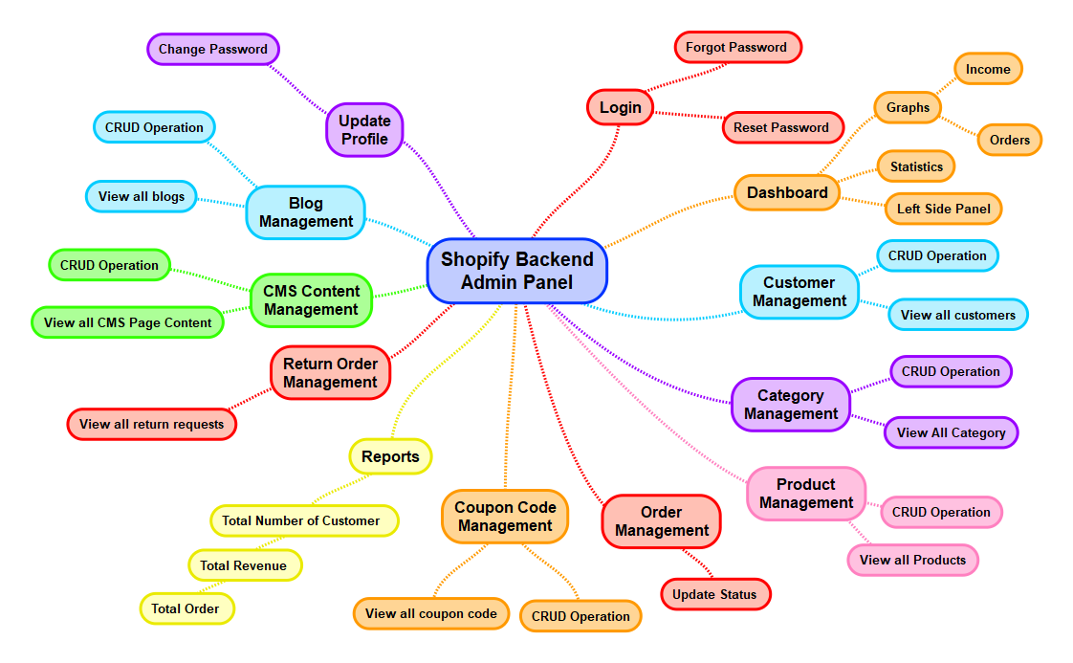

## Shopify Admin Panel Management

1. **LOGIN** 
   1. Admin should be able to login into the backend admin panel.
   2. Admin can enter following fields on this page to login into the backend admin panel:
      1. Email Address
      2. Password
      3. Login button
      4. Forgot password link
   3. **Navigation**:
      1. By clicking on login button, system will check credentials and if all credentials are correct then system will navigate admin to the “**Dashboard**” page.
      2. By clicking on forgot password link, system will navigate admin to the “**Forgot Password**” page.
2. **FORGOT PASSWORD**
   1. Admin should be able to enter their email address to reset their backend credentials.
   2. Admin can enter the following fields on this page to login into the backend admin panel:
      1. Email Address
      2. Reset Button
   3. **Navigation:** By clicking on reset button, the system will send an email on entered registered email address along with reset password link. By clicking on reset password link, system will navigate admin to the Reset Password page.
3. **RESET PASSWORD**
   1. Admin should be able to enter required fields to update their backend credentials.
   2. Admin can enter following fields on this page to login into the backend admin panel:
      1. New Password
      2. Confirm Password
      3. Update Button
   3. **Navigation:** By clicking on update button, the system will store updated credentials in database for the admin account and system will navigate admin to the “**Login**” page.
4. **DASHBOARD**
   1. Admin can view different statistics on the dashboard as below:
      1. Total Number of Products
      2. Total Number of Orders
      3. Pending Orders
      4. In-progress Orders
      5. Cancelled Orders
      6. Completed Orders
      7. Return Order Requests
   2. Admin can view a total number of income for the particular month wise on the dashboard in a graph view
      1. X = Month
      2. Y = Income
   3. Admin can view a total number of order for the particular month wise on the dashboard in a graph view
      1. X = Month
      2. Y = Order
   4. Along with the above details admin can view following menu on left side:
      1. Dashboard
      2. Customer Management
      3. Category Management
      4. Product Management
      5. Order Management
      6. Contact Requested Form
      7. CMS content Management
      8. Promo Code Management
      9. Return Orders Management
      10. Blog Management
      11. Report Management
      12. Update Profile
      13. Change Password
      14. Logout
   5. Once admin click on particular menu system will navigate admin to particular associated page.
   6. Dashboard will be display as per Shopify Framework Admin Panel Standard and Structure
   7. We have not consider any type of customization for Dashboard of Shopify admin panel. If any customization required then we will check feasibility and then we will inform to the client with separate cost and time estimation.
5. **CUSTOMERS MANAGEMENT** 
   1. Admin can view all the list of customers that are registered into web platform with below details:
      1. Profile Picture
      2. First Name
      3. Last Name
      4. Email Address
      5. Mobile Number
      6. Address
      7. City
      8. State
      9. Country
      10. Post/ Zip Code
   2. Admin can perform various operations like Update/Delete/View.
   3. Customer management would be as per Shopify Admin Panel standards and structure.
6. **CATEGORY MANAGEMENT** 
   1. Admin can view all the list of Category that are published on the web platform in this section:
      1. Category Name
      2. Category Image
   2. Admin can Add a new category by entering the below form fields:
      1. Category Name
      2. Category Image
   3. Admin can update a particular category’s information by clicking on update button/ icon.
   4. Admin can delete particular category from available list by clicking on delete button/ icon.
   5. Category management would be as per Shopify Admin Panel standards and structure.
7. **PRODUCT MANAGEMENT** 
   1. Admin can view all the list of products that are published on web platform in this section with below details:
      1. Product Image
      2. Product Name
      3. Product SKU Code
      4. Product Category
      5. Product Price
      6. Product Detail Description
      7. Status
         1. Active
         2. Inactive
   2. Admin can add a new product by entering required form fields as above.
   3. Once admin enters value of above fields and click on add product button, the system will add a new product into the platform and it will be display on the web platform.
   4. Admin can update a particular product’s information by clicking on update button/ icon.
   5. Admin can delete a particular product from available list by clicking on delete button/ icon.
   6. Product management section would be as per Shopify Admin Panel standards and structure.
8. **ORDER MANAGEMENT**
   1. Admin can view all the list of orders that are placed by the different Customer s on the platform in this section with the below details:
      1. Order Id
      2. Order Date & Time
      3. Customer Name
      4. Customer Email Address
      5. Customer Contact Number
      6. Product Name
      7. Product Category
      8. Product Price
      9. Total Number of Quantity
      10. Shipping charges
      11. Tax Amount
      12. Delivery Charges
      13. Promo Code Applied
          1. Discount Amount
      14. Total Amount Paid
      15. Status
          1. Pending
          2. In Progress
          3. On the way to deliver
          4. Completed
          5. Cancelled
          6. Returned
   2. Admin can change the status of the particular order from pending to in progress to on delivery to completed by selecting the particular option from dropdown.
   3. Order management section would be as per Shopify Admin Panel standards and structure.
9. **CONTACT REQUESTED FORM**
   1. Admin can view all the list of the customer who have inquired or have a query related to the web platform in this section with below details:
      1. Your First Name
      2. Your Last Name
      3. Your Email Address
      4. Your Phone Number
      5. Subject
      6. Message
      7. Submitted date & Time
   2. Contact requested management section would be as per Shopify Admin Panel standards and structure.
10. **BLOG MANAGEMENT** 
    1. Admin can view all the list of the blogs/articles that are published on the platform with below details:
       1. Blog Title
       2. Blog Category
       3. Blog Thumbnail Image
       4. Blog Publisher Name
       5. Blog Published Date
       6. Blog Updated Date
       7. Blog Updated by
       8. Status
          1. Active
          2. In-active
          3. Draft
       9. Action
          1. View
          2. Edit
          3. Delete
    2. Admin can perform various operations like Create, Read, Update, and Delete functionality on this section
    3. Blog Management section would be as per Shopify Admin Panel standards and structure.
11. **CMS CONTENT MANAGEMENT**
    1. Admin should able to manage the following below content:
       1. Home Page (Different Section Content)
       2. Terms and Conditions
       3. FAQs
       4. Refund Policy
       5. Copyright text
       6. About us
       7. Contact us
    2. Admin can perform the CRUD (Create, Update, Delete, and Read) functionality on this section.
    3. CMS content management section would be as per Shopify Admin Panel standards and structure.

1. **RETURN ORDER MANAGEMENT**
   1. Admin can view all the list of return request that are submitted by the different customers on the web platform in this section with the below details:
      1. Order ID
      2. Order Date & Time
      3. Customer Name
      4. Customer Email Address
      5. Customer Mobile Number
      6. Return order Request Date
      7. Return Reason
      8. Return Issue
      9. Comment/ Description
2. Return related functionality will be managed outside the platform manually.
3. Once admin received return order product and verified it, they can transfer the particular refund amount to the customer account through which customer has make payment on the web platform.
4. Payment Send functionality will be done the web platform by the administrator.
5. For Return order management, we will integrate 3rd party App into the web platform. If 3rd party shopify App is purchasable then client will purchase it and provide us with all the necessary details.
6. Return Order Management Section would be as per the 3rd party Shopify App and Shopify Admin Panel standards and structure.
7. **PROMO CODE MANAGEMENT**
   1. Admin can view all the list of promo code that are created by themselves in this section with below details:
      1. Promo Code Name
      2. Promo Code Description
      3. Promo Code
      4. Promo Code Expiry Date
      5. Discount Type
         1. Flat
         2. Percentage
   2. Admin can create a new promo code by entering the following form fields:
      1. Promo Code Name
      2. Promo Code Description
      3. Promo Code
      4. Promo Code Expiry Date
      5. Discount Type
         1. Flat
         2. Percentage
   3. Admin can update the particular Promo code’s information by clicking on update button/ icon
   4. Admin can delete particular Promo code from the available list by clicking on delete button/ icon
   5. Promo code management would be as per the Shopify Admin Panel standards and structure.
8. **REPORTS**
   1. Admin can view and download report for below options:
      1. Total Number of Customer
      2. Total Income
      3. Total Order
   2. Admin can generate the report by selecting the following options wise:
      1. Day Wise
      2. Week Wise
      3. Month Wise
      4. Year wise
   3. Custom Date Range: Once admin click on this option, the system will display two fields as below:
      1. Start Date
      2. End Date
   4. Once admin select the start date and end date using the calendar and click on the report button, the system will generate a particular reports based on the selected date and display the data to the admin on this section.
   5. By clicking on the download button, the system will download the particular reports data into an excel sheet on the admin’s desktop.
   6. Report management would be as per the Shopify Admin Panel standards and structure.
9. **CONFIG MANAGEMENT**
   1. Admin can set and manage following configuration of the web platform separately in this section as below:
      1. Shipping Charges
      2. Transaction Fee/ Services Charges
      3. Delivery Charges
      4. Tax
10. **UPDATE PROFILE**
    1. Admin should be able to view and update their backend admin panel profile details through this section.
       1. First Name
       2. Last Name
       3. Email Address
       4. **Update Button:** By clicking on update button, the system will store all data into the database into particular admin account that are updated by the admin and display a toast message “Profile Updated Successfully” To the admin.
11. **CHANGE PASSWORD**
    1. Admin should be able to change their backend admin panel account credentials through this screen.
    2. Admin can enter the below fields to update their backend admin panel credentials:
       1. Old Password
       2. New Password
       3. Confirm Password
       4. **Update button:** By clicking on it, the system will store credentials into the database into particular admin account that are updated by the admin and display a toast message “Password Updated Successfully” to admin.

**Note:**

* **All the content and images that are required for the web platform will be provide by clients.**
* **Responsive Frontend web platform will be develop as per the HTML structure and standard**
* **Home page will be developed as per the HTML Structure and Shopify E-Commerce Standard.**
* **Product Listing, Product Detail page and My Account page will be developed as per the Shopify E-Commerce Standard.**
* **Frontend Web Platform will be developed as per the Shopify E-Commerce** **Standard and structure.**
* **Shopping Cart and Checkout Page will be developed as per the Shopify E-Commerce** **Standard. If there is any other customization or addition changes required then we will provide separate cost and time estimation.**
* **Shopify Backend admin panel will be as per the Shopify E-Commerce** **standard and in English language only.**
* **All the 3rd party Apps or library that are required for the web platform development will purchase by the client & provide us with all the necessary details.**
* **3rd Party Payment Gateway and Shipping Cost Integration related information will be provided by the client at the time of the development.**

# Team Details

|  |  |  |
| --- | --- | --- |
| **PROFILE** | **NO OF RESOURCES** | **EXPERIENCE** |
| Project Lead | 1 | 8+ Years |
| UI/UX Expert | 2 | 6+ Years |
| Shopify Developers | 2 | 5+ Years |
| Quality Analyst | 1 | 5+ Years |
| Total Team Size | **06 Resources** | |

# Deliverables

|  |  |
| --- | --- |
| **PROJECT MANAGEMENT** | Pro-active consultation |
| SCRUM based execution |
| **DESIGN** | Custom Web Design |
| Responsive HTML (Mobile & Tablet Friendly) |
| **WEBSITE DEVELOPMENT** | Website Development |
| **BACKEND DEVELOPMENT** | Database Design |
| Rest API Development |
| Shopify Admin Web Panel Development |
| **QUALITY ASSURANCE** | Manual Unit Testing |
| Adhoc Testing |
| **VALUE ADDED SERVICE** | Web Platform Deployment on client’s server |
| Deploy REST APIs on client’s server |
| 3 Months Post deployment Warranty (for any bugs/ errors) |
| **DEPLOYMENT** | Client will provide ready server for CMARIX team to deploy. |

# Warranty

|  |  |
| --- | --- |
| **Warranty Period** | 3 Months Post deployment Warranty (for any bugs/ errors) |

As a part of this proposal, CMARIX will provide above Warranty Period – which applies immediately post deployment including unlimited support for fixing any bugs or error based on the defined scope of work.

Any changes made to code or server by anyone other than CMARIX will lead to void of warranty. Thereby, corresponding fixes will not be covered under the warranty coverage.

Warrant coverage is only for fixing any bugs / errors. It does not cover any changes, feature addition or any out of scope items.

# Maintenance Service Contract

Service is more important than sales. At CMARIX, we firmly believe this and take pride in providing ongoing maintenance service to our customers. Following are different Maintenance Service packages to suit your business needs:

|  |  |  |  |
| --- | --- | --- | --- |
| **Duration** | **Per Hour Rate** | **Hours** | **PRICE (USD)** |
| 3 Months |  | 50 |  |
| 6 Months |  | 100 |  |
| 12 Months |  | 200 |  |

Maintenance Contract is highly recommended for any software platform to ensure smooth operations.

CMARIX - Maintenance services include fixing bugs, implementing changes as well as feature addition. We strongly recommend client - to not give code access or rights to make code changes to anyone other than CMARIX during this maintenance period.

# Commercial Terms

## Price & Timeline

|  |  |
| --- | --- |
| **PROJECT PRICE** | $ USD |
| **TIMELINE** | Around weeks |

## Milestone

|  |  |  |  |
| --- | --- | --- | --- |
| **#** | **MILESTONE** | **AMOUNT IN %** | **AMOUNT IN USD** |
| **1** | Award of Project | 20% |  |
| **2** | After Design confirmation | 30% |  |
| **3** | Web Platform Initial Demo | 30% |  |
| **4** | After Final Demo | 20% |  |
|  | Total | 100% |  |

## Payment Mode

|  |  |  |
| --- | --- | --- |
| **OPTION #** | **PAYMENT METHOD** | **NOTES** |
| **1** | Wire transfer | Additional $40 USD fees would be applied/ Invoice |
| **2** | PayPal | Additional 5.5% PayPal fees would be applied/ Invoice |

# Technology Stack

**WEB PLATFORM DEVELOPMENT**

|  |  |
| --- | --- |
| **PLATFORM** | **SPECIFICATION** |
| **OPERATION SYSTEM** | Linux |
| **WEB SERVER** | Shopify |
| **DEVELOPMENT ENVIRONMENT** | Shopify Framework + MySQL |

**FRONTEND BROWSER COMPATIBILITY**

|  |
| --- |
| **SUPPORTED BROWSER** |
| Google Chrome (Latest Version) (Windows, MAC Desktop, Mobile, iPad & Tablet) |
| Firefox (Latest Version) (Windows, MAC Desktop, Mobile, iPad & Tablet) |
| Safari (Latest Version) (MAC Desktop, Mobile, iPad & Tablet) |
| Microsoft Edge (Latest Version) (Windows, Mobile, iPad & Tablet) |

**FRONTEND RESPONSIVE BROWSER COMPATIBILITY**

|  |  |
| --- | --- |
| **SUPPORTED BROWSER** | |
| 1900 X 1200 | 1366 X 768 |
| 1024 X 768 | 1024 X 1366 |
| 1280 X 800 | 414 X 736 |
| 375 X 667 |  |

# Our Portfolios

## Mobile Application

## Web Platform

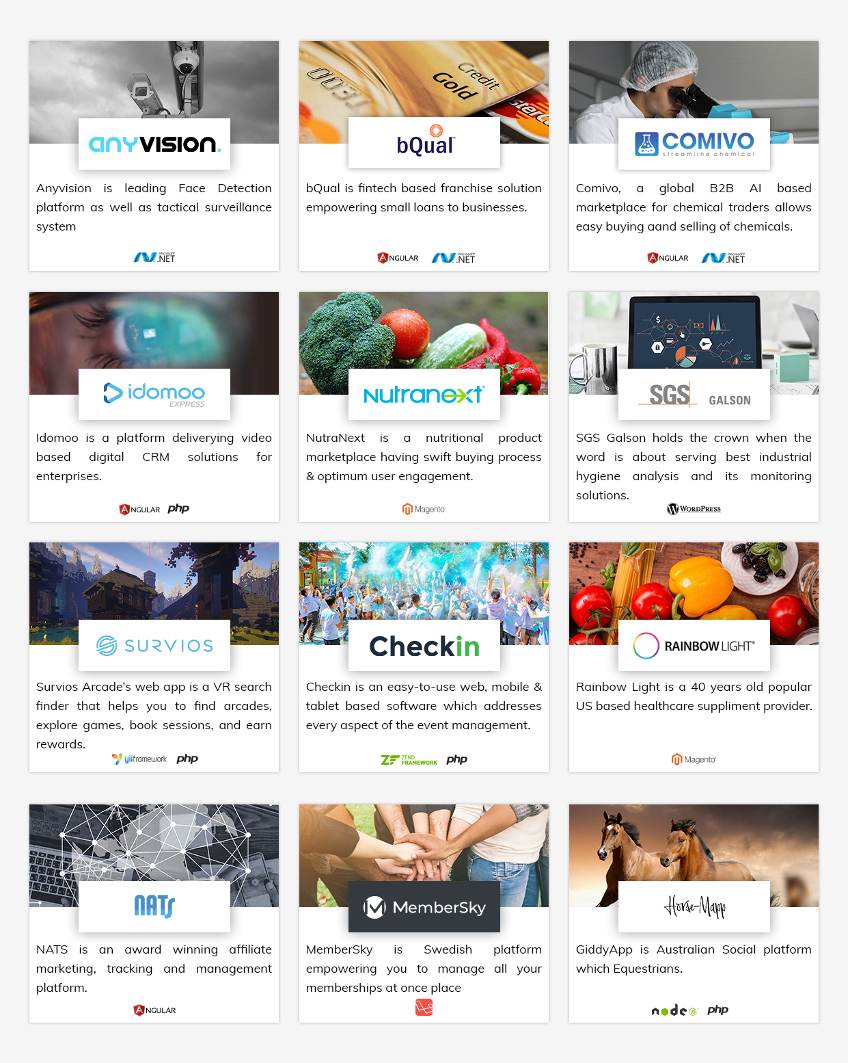

# Our Certification

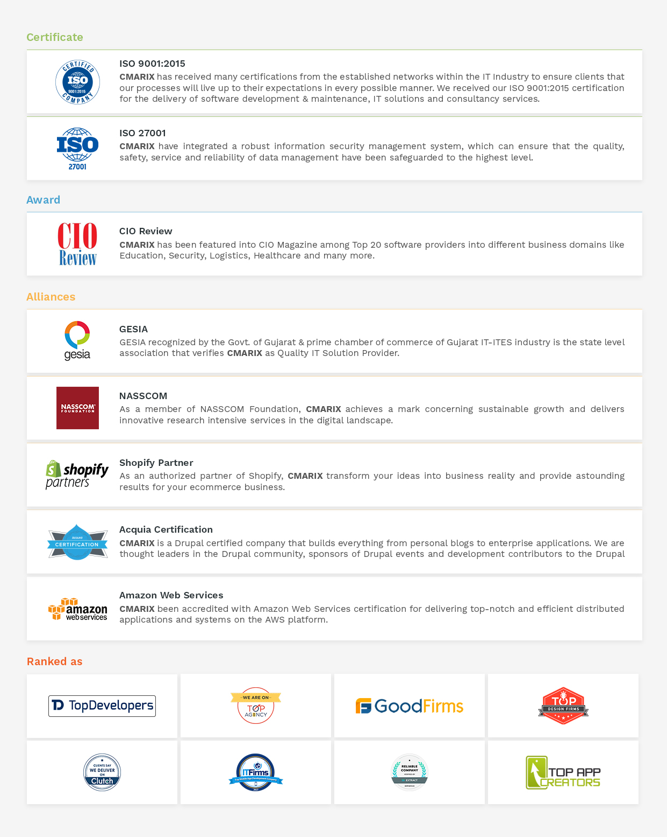

# Our Valuable Clients

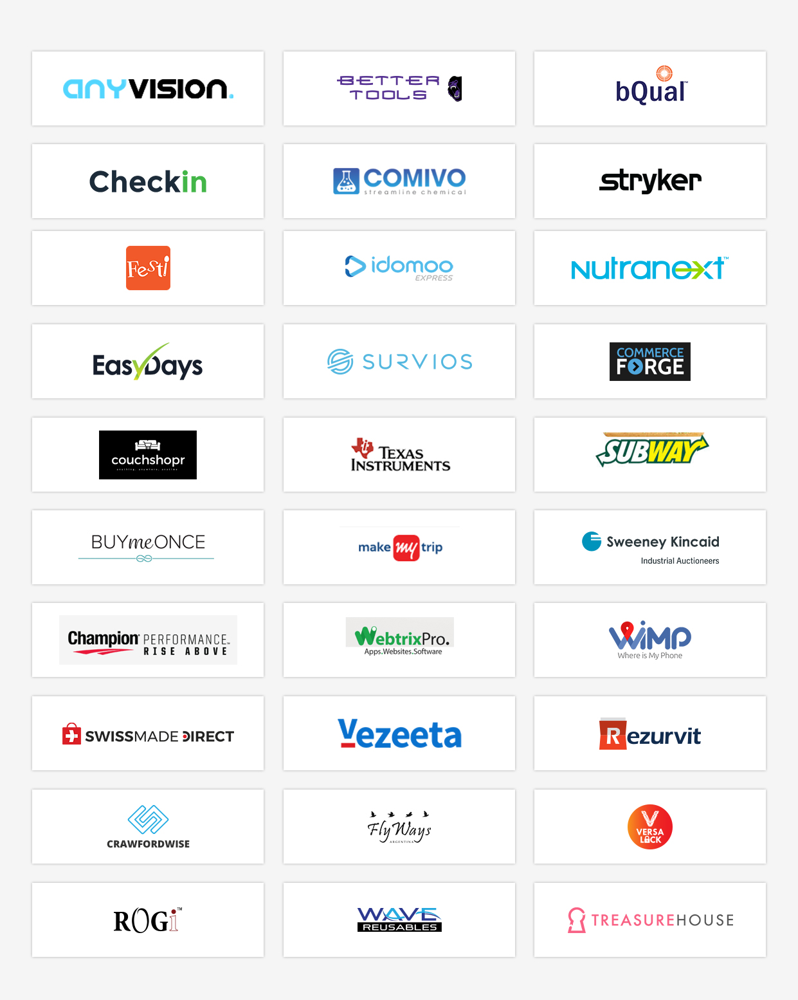

# Change Request Management

CMARIX will be happy to accommodate any additional features or functionality using the Change Request Management Process, whereby we will outline the task list & provide corresponding time & cost estimation for the same. Based on client’s approval we will implement the same. Any item which is not included in current scope of work would be part of change request management process.

1. **Definition of Change Request:**

Any features or functionality which are not part of confirmed project proposal.

Any changes in features or functionality once the design is confirmed & development has started.

1. **Definition of Add-ons:**

Addition of any new feature or functionality which is not part of confirmed project proposal.

# Exclusion

Following items are NOT included in the given proposal and clearly excluded.

1. **Development of Detailed Technical Functional Specification**

Detail functional specification is not included in this proposal execution. Scope document will be the base document for the requirements.

1. **Out of Scope**

Any and all features which are NOT defined in the scope of work of this document will be out of scope and can be implemented as per standard Change Request Management process, if required.

# Assumption

We have considered below assumptions while working on current understanding.

|  |  |
| --- | --- |
| **TOPIC** | **ASSUMPTION** |
| **DESIGN** | The client will provide a logo and color pallete for the web platform. Client will purchase a theme and provie us with the source code. We will create Frontend Responsive web platform Development as per the purchase theme HTML Structure and Shopify Framework Structrue & standard. |
| **MULTILINGUAL** | The Frontend Responsive Web platform will support the “**English”** language only. Shopify admin panel will be in the English language only. |
| **3RD PARTY TOOL** | Customer will need to buy/purchase a license for any pre-approved 3rd party tools/extension/API which is going to be integrated into the Web Platform |
| **CONTENT** | We assume that the entire Static CMS Content-related to the Frontend Web Platform will be provided by the client. Content means text, images, and other assets. |
| **DOCUMENTATION** | CMARIX has not considered the development of any documentation on this Project. In the case of an additional request, CMARIX can provide charges separately. |
| **DEPLOYMENT** | For Deployment, we assume the client will provide  - cPanel detail with full access  - PhpMyAdmin with full access  - The domain should be pointed to the server  - Full FTP access  - Pre-installed SSL certificate on Server (if applicable) |
| **DATA ENTRY** | Data Entry and Data Migration Services is not included in the current scope of work. We can provide this as an additional services, if required. |
| **ANIMATION** | Animation of any kind is not included in the current scope of work. |

# Ownership

In consideration of and effective upon CMARIX receipt of all payments required hereunder with respect to a specific Application, and provided that Customer is not otherwise in material default of any provision of this Agreement or any Project Appendix, CMARIX acknowledges and agrees that Ownership of the complete product will belong to the customer. In consideration of and effective upon CMARIX receipt of all payments required hereunder, CMARIX hereby grants to Customer exclusive, transferable license, with the right to sublicense, to use, copy, operate software created by CMARIX.

## Publicity

Upon Customer's prior written consent in each instance, CMARIX may use Customer's logo and trademarks, and any work produced for the Customer by CMARIX, for promotional use both in printed and online portfolio formats, provided that no such disclosure shall result in the breach of CMARIX confidentiality obligations under this Agreement.

## References

CMARIX may refer to the Services performed under this Agreement and to CMARIX relationship with Customer without disclosing Confidential Information in resumes and experience/qualification summaries; provided, that such resumes and summaries shall not suggest that Customer endorses or recommends CMARIX work without Customer's prior consent.

# Project Management Approach

## Introduction

Project Management activity is an umbrella activity that will span the entire project lifecycle. Our Project Management processes are based on the PMBOK ® knowledge areas & SCRUM based Agile Execution.

***Initial Kick-off Meeting:***

A project "kick-off" meeting with the Client team would signify the start of the project. A project manager is designated to manage the project, CMARIX Team of designers, developers and QA engineers.

Client would also designate a one-person coordinator who interacts with our team on all aspects of implementation and takes all relevant decisions with regard to the implementation of the system. We strongly recommend there to be single point of contact from client for effective collaboration.

Project Purpose and Scope, Client Information and Client’s Expectations, Delivery schedule with associated milestones and financials, Roles and Responsibility Definition, Details of the First milestone, General Coding Guidelines, third-party integrations, Client dependency sheet and assumptions, Major Risks and Process Tailoring are discussed during project kickoff and documented in Project Initiation Note.

***Project Planning and Work Allocations:***

The purpose of the Software Project Planning is to establish reasonable plans for performing the software engineering tasks and for managing the software project. We possess expertise in using diverse Project Management tools for project scheduling and tracking which covers tracking and scheduling through Gantt Charts and other industry standard tracking techniques. Apart from using tools like Trello, Jira, Basecamp, and Asana for planning and scheduling, we also use our in-house Intranet Application for project execution. Allocations are done using this application against which each resource fills up daily time sheets listing the activities done during the day.

A comprehensive Project plan is prepared, which outlines all the critical aspects related to the smooth project execution. These include:

* General Planning and Milestones
* Scope Management
* Team formation and Engagement
* Integration Planning
* Communication Planning
* Quality Management
* Risk Management and Mitigation
* Tracking and Control

## Project Monitoring and Tracking

When the project is initiated, the team has communicated the details of the project along with its milestones. Details of each milestone are clearly communicated across the team to ensure that everyone is aware of the entire project timeline.

Once the project starts, in the planning phase itself, we will outline the Quality Plan. All the activities, work-product reviews, and inspections that aim quality will be outlined in the quality plan. Quality plan will be reviewed/approved and will be kept at the central point of access. Project Manager keeps a tab on all the quality related activities throughout the project execution to ensure that the project meets the specified quality requirements.

Dedicated SQA member(s) take care of all the incremental and functional testing. SQA will also ensure that the defined processes are followed in the project.

Project will closely be tracked against the established plan and any deviations therein will be promptly reported to the client along with the suggested corrective actions.

The planned v/s. actual progress is tracked by Project Manager periodically to ensure that the project abides by the established timeline. It also enables Project Manager to keep Client’s abreast of the progress of the project on a periodic basis.

Project status reviews are done internally with the team periodically (E.g.: Weekly, Fortnightly etc. as agreed). Project status meetings and updates to Client will be given using the Project Status Review document. The status of ongoing work will also be given to Client by demonstrating the ongoing work through collaborative tools like GoToMeeting.

|  |  |  |
| --- | --- | --- |
| **ACTIVITY** | **PROCEDURE** | **TOOL USED (IF ANY)** |
| Scheduling | The Project Manager would perform scheduling and re-scheduling. The team members will be assigned their tasks by PM and the module leaders (if any) | The work allocation will be prepared in an excel sheet and the same will be communicated to the concerned persons. |
| Project Meeting (Internal) | Periodical internal meetings. Both technical and managerial aspects would be discussed. Minutes of Meetings would be recorded and tracked. | NA |
| Status Review Meetings  With Senior Management  With CLIENT | Periodical Project Status Review Meetings with senior management. Minutes of Meetings would be recorded and tracked.  Ad-hoc meetings would be held to resolve any issues. | NA |

**Tracking of Issues**

|  |  |  |  |
| --- | --- | --- | --- |
| **ISSUE TYPE** | **PROCEDURE** | **LEVELS** | **ESCALATION PROCEDURE** |
| Project Internal issues & Support Issues | Internal issues of the project would be resolved during the periodical internal meetings. Project Manager and Module Leader together are responsible for resolving or escalating such issues. | Level 1 | If the internal issues are not resolved within 3 working days, the issue would be escalated to Escalation Manager. |
| Customer Issues | Customer will be updated by Project Coordinator from CMARIX to Customer.  The change requests will be sent by the customer to the PM | Level 2 | If the issues are not resolved within 7 working days, the issue would be escalated to Delivery Manager |

## Communication

We proposed the following guidelines to be used for documentation and communication for effective project management.

* Any transfer of the documentation from either side will be done in MS Word, PDF or MS Excel sheets in soft copy formats via electronic media. Document standards will be made available. All the documents should be in the English Language.
* The project team will review progress at the regular weekly staff meetings
* CLIENT and CMARIX will briefly talk every week to assess the overall progress of the project and issues that may be impeding its movement
* Modes of communication
  1. Slack / Skype
  2. Google Meet / Zoom
  3. Email
* Frequency of Communication
  1. Daily (Depending on the sprint planning)
  2. Weekly Peer Reviews
  3. Client Meeting [fortnightly]
* Complete Contact information of the Project Managers from either side will be made available at the start of the project
* Stakeholders Responsible for communication
  1. Project Manager, CMARIX
  2. Project Manager, CLIENT
* Finalization of ongoing Intermediate Communication
* Minutes of Meeting to be signed off by Project Managers

# Term And Condition

**DISCLAIMER:**

* CMARIX follow all its communication and documentation in English language only.
* CMARIX may display the project on its portfolio as well as other partner sites after successful completion of work.
* In the case of any Projects which are under confidential agreements, CMARIX will only use Logo of the Project for display/marketing purpose.

**PRICE and PAYMENT TERMS:**

* Submitted Proposal Estimation is valid for 15 days from the date of proposal sent, In case of any approvals after 15 days are subject to reconfirm with CMARIX business team
* Cost of infrastructure, hardware, server software and network required at customer’s end are excluded from CMARIX proposition.
* CMARIX proposition does not include any costing of additional services such as domain registration, hosting, payment gateway or any third party charges.
* In the case of any emergency closure/termination of the project requested by the customer, CMARIX will seek payment for the work done till date as per resources engaged in Project before we treat project as CANCELLED or CLOSED.
* CMARIX will NOT provide any refunds to the customer.
* While making payment, the purpose of payment should be “Web/ Mobile Development Charges”.
* Client will have to provide necessary signed documents required for accounting purpose in accordance with this proposal.
* Payment needs to be cleared within 5 days of Performa invoice received by the company.
* Client has to make the payment as per the payments terms mentioned in the proposal.

**SCOPE:**

* Company Logo creation/development will not be a part of the Project development unless agreed as a part of scope section.
* Any change request from a customer while execution of the Project after wireframes and designs approval stage will go through Change Request Process as defined earlier in this Proposal document.
* Data migrations from Old Projects/Application to new Site/Application are out of scope unless defined as part of scope section.

**PAYMENT MILESTONES:**

* *Award of Project Milestone* refers to the first payment milestone requested as a formal approval of the project. Once client provides this CMARIX will plan team allocation and finalize the start date of the project.
* *Design Confirmation* *Milestone* refers to the payment that needs to be processed by the client when the designs provided by CMARIX are finalized. Once payment of this milestone is made, project execution plan will be provided and project development will start.
* *Design Integration Milestone* refers to the frontend design integration in the application. In this milestone only design integration is completed and shared with client. Client can click on each and every elements (i.e. buttons, images, links, animation) and can see or navigate to respective screens. This demo doesn’t include any kind of development/ programming. It will be a clickable design.
* *Initial Demo Milestone* refers to the work-in-progress demo provided to client. Please note that no feedback, quality check or client review is required on this milestone as its work in progress. Demo details for this milestone will be defined by the Project Manager in the detailed project plan.
* *Final Demo Milestone* refers to the final payment that needs to be processed by the client when final demo is provided by CMARIX. This demo will be provided on CMARIX staging server ONLY. Once corresponding payment is made, than CMARIX will proceed forward with delivery of the source code and launch.
* CMARIX accounts will raise invoice when corresponding milestone is achieved. Payment should be made within 5 working days of the invoice date. In case there is delay in payment of more than one week, than CMARIX will put the project officially ON HOLD.
* Once the project is ON HOLD additional 10% cost of the entire project will be added up in a final milestone of the project payment, considering the bench cost, additional overhead of resource allocation / de-allocation etc.

**ESTIMATION:**

* CMARIX has provided this Proposal based on business understanding and scope defined by customer till date. At the time of requirements analysis and design / wireframe stage if any major is risk identified it will be shared with the customer and revised efforts in terms of time and cost will be submitted for approval before going into next step of SDLC.
* Provided estimation does not include any data entry, content writing or templates creation work.
* It is client’s responsibility to ensure they have revised the detailed scope of work based on which estimation is provided.

**RESOURCES UTILIZATION:**

* CMARIX assumes that customer would provide one project manager and functional expert(s) during Requirement Analysis and Knowledge Acquisition phase.
* CMARIX do not have any control on third-party software or vendors, so the customer will have to take care of the complete responsibility for any third party vendor’s dependency or faulty products and consequences arising out of such usage.

**PROJECT AND CODE DELIVERY:**

* This is a Fixed Cost Proposal for which source code delivery will be provided AFTER the final demo and final payment milestone is cleared by client. Source code will be delivered once 100% payment is made.
* CMARIX does NOT keep backup of client’s project once delivered. Once project is delivered it is client’s responsibility to keep back of the project code and corresponding assets.

**TIME BOUND CLAUSES:**

* CMARIX assumes that all sign-offs from customer will be provided within agreed and specified timeframe. Such time frame can be decided at the beginning of each key milestone/activity between customer and development team.
* It is requested that the customer will provide confirmation/approval for requested stages as & when required within 2-3 business days. It is expected that Client will resolve queries in reasonable time frame. Any delay can result in slippage of the schedule agreed.
* In case if there no response or a delay from a client with regards to the response to queries or feedback which affects to the overall planning of the Project and resources sitting idle, longer than a week, than the project will be put ON HOLD and additional 10% cost of the entire project will be added up in a final milestone of the project payment.
* For any circumstances, if the project needs to be put on Hold by either party (customer or developer) it requires minimum request notice period of 1 week along with duration for how long this has to be kept on HOLD. In both cases the request will be addressed by CMARIX management and final conclusion will be made.
* CMARIX will require a lead-time of the 1-2 week to start the project after the project is awarded.
* In case customer requires any extension or delay on the proposed acceptance schedule, the associated effort and cost of such extension can be mutually agreed if needed.

## Terms of Acceptance

These General Terms and Conditions and all Project Appendices constitute the entire agreement between the parties and supersede all previous negotiations, agreements, and other communications, whether oral or written, relating to the subject matter of this Agreement. Any variance from or addition to the terms of this Agreement contained in any purchase order or other written notification will be of no effect. This Agreement may not be assigned by either party without the prior written consent of the other, except for assignments to affiliated entities or to a successor company whether by merger, acquisition or a sale of substantially all of the party's assets. This Agreement may not be modified in any way except in writing signed by both parties. This Agreement shall be governed in all respects by the laws of the states of Gujarat, India. The invalidity or unenforceability of one or more provisions of this Agreement shall not affect the validity or enforceability of any of the other provisions, and this Agreement shall be construed in all respects as if such invalid or unenforceable provisions.

**SIGNED BY THE PARTIES OR THEIR DULY AUTHORISED REPRESENTATIVES**

|  |  |  |
| --- | --- | --- |
| **CUSTOMER POINT OF CONTACTS** | **FIRST CONTACT** | **ALTERNATE CONTACT** |
| **FULL NAME** |  |  |
| **COMPANY NAME** |  |  |
| **DESIGNATION** |  |  |
| **DATE** |  |  |
| **SIGNATURE** |  |  |

# Acceptance Criteria and Procedure

Client will perform acceptance testing of the deliverables on their systems. CMARIX team will assist the acceptance-testing phase. Any issues reported during the Acceptance Testing will be analyzed and categorized as "Defects" or "Change Requests (CRs)". Problems arising due to the defects in the realization from the starting points will be categorized as Problem Reports and rectified by CMARIX. CMARIX will attempt to solve the problems reported at the earliest. In case the estimated time for solving the problems is going to be significant, it will be communicated to the Client.

**Formal Acceptance Testing** will start after CMARIX sends the final delivery. CMARIX will make out a formal Delivery Note to the Client. Client will acknowledge, review the work and approve the delivery as complete and acceptable or incomplete and unacceptable, within the number of days of delivery being made as mentioned below. If rejected, CMARIX will rework the software to requirements.

The scheduled acceptance period, for the completed delivery, would depend on the release.

CMARIX uses following defect classification:

|  |  |
| --- | --- |
| **TYPES** | **DESCRIPTION** |
| P0 | Fatal Error. A runtime error occurs which causes the application to crash. |
| P1 | No Fatal Error, but functionality differs from the specification. |
| P2 | Error wherein the software works but a degree of inconvenience is caused. Correction is not deferrable and an easy workaround exists. |
| P3 | Cosmetic errors like navigational errors, object positioning on the screen etc. |

CMARIX will fix all P0 and P1 defects reported during acceptance. Conditional Acceptance will occur for P2, and P3 defects. A defect will be treated as "fixed" once the problem identified in the defect report is corrected and Client verifies the correction.

All project deliverables included as part of the final deliverable of each will be "Deemed Accepted", if no errors have been reported or if no communication to any effect is received from Client within 7 calendar days after the final deliverables. CMARIX will notify Client via e-mail that the deemed acceptance has occurred.

